AP CSP Python with Robots  Binary Numbers Activity Guide |  |  |  |  |  | Name:
Warm Up What do you remember about binary numbers?
Activity #1 REVIEW: Get a flippy-do. Use it to convert a binary to decimal, and a decimal to binary.
Binary |  |  | Decimal |  |  | Decimal |  |  | Binary
0000 0011 |  |  |  |  |  | 6
0001 0001 |  |  |  |  |  | 16
0010 1101 |  |  |  |  |  | 35
0110 0010 |  |  |  |  |  | 110
1001 1011 |  |  |  |  |  | 141
Activity #2 REVIEW: Binary numbers in code. Write the Python code using decimal numbers that will light up the LEDs as displayed. You can test your code on CodeBot.
Light up these LEDs: |  |  |  |  |  |  |  | Python Code (decimal)
 |  |  |  |  |  |  |  | leds.ls(4)
 |  |  |  |  |  |  |  | leds.user(74)
Activity #3 Binary numbers applications. Use your knowledge of binary to answer the application questions.
- There are 30 students in your class. You want CodeBot to display the number of students in class on a particular day, using LEDs and binary. How many LEDs are required to display up to 30 students?
- An online store uses 6-bit binary sequences to identify each unique item for sale. The store plans to increase the number of items it sells and is considering using 7-bit sequences instead of 6-bit sequences. Which of the following best describes the result of using 7-bit sequences instead of 6-bit sequences?
  - 2 more items can be uniquely identified.
  - 10 more items can be uniquely identified.
  - 2 times as many items can be uniquely identified.
  - 10 times as many items can be uniquely identified.
- A certain programming language uses 4-bit binary sequences to represent non-negative integers. For example, the binary sequence 0101 represents the decimal value 5. Using this programming language, a programmer attempts to add the decimal values of 14 and 15 and assign the sum to the variable total. Which of the following best describes the result of this operation?
  - The correct sum of 29 will be assigned to the variable total.
  - An overflow error will occur because 4 bits is not large enough to represent either 14 or 15.
  - An overflow error will occur because 4 bits is not large enough to represent the sum 29.
  - A round-off error will occur because 14 and 15 are represented as approximations due to the fixed number of bits used to represent numbers.
- ASCII is a character-encoding scheme that uses 7 bits to represent each character. The decimal (base 10) values 65 through 90 represent the capital letters A through Z, as shown in the table below.
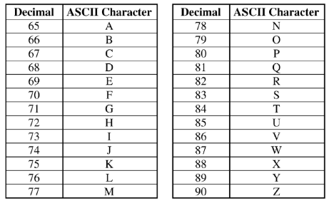
What ASCII character is represented by the binary (base 2) number 1001011?

- The player controls in a particular video game are represented by numbers. The controls and their corresponding binary values are shown in the following table.
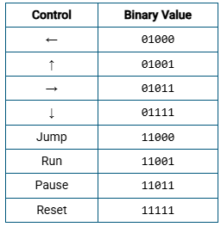
The numeric values for the controls can also be represented in decimal (base 10). What is the decimal value for the Pause control?

- A color in a computing application is represented by an RGB triplet that describes the amount of red, green and blue, respectively, used to create the desired color. A selection of colors and their corresponding RGB triplets are shown in the following table. Each value is represented in decimal.
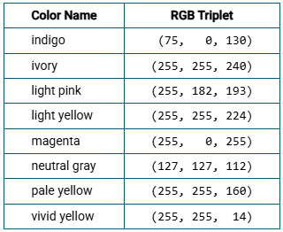
What is the binary RGB triplet for the color neutral gray?

- The position of a runner in a race is a type of analog data. The runner’s position is tracked using sensors. Which of the following best describes how the position of the runner is represented digitally?
  - The position of the runner is determined by calculating the time difference between the start and the end of the race and making an estimation based on the runner’s average speed.
  - The position of the runner is measured and rounded to either 0 or 1 depending on whether the runner is closer to the starting line or closer to the finish line.
  - The position of the runner is predicted using a model based on performance data captured from previous races.
  - The position of the runner is sampled at regular intervals to approximate the real-world position, and a sequence of bits is used to represent each sample.
- Which of the following are true about the data that can be represented using binary sequences?
- Binary sequences can be used to represent strings of characters.
- Binary sequences can be used to represent colors.
- Binary sequences can be used to represent audio recordings.
- I only
- I and II only
- II and III only
- I, II and III
9. A store uses binary numbers to assign a unique binary sequence to each item in its inventory. What is the minimum number of bits required for each binary sequence if the store has between 50 and 60 items in its inventory?

10. A binary number is to be transformed by appending two 0s to the end of the number. For example, 11101 is transformed to 1110100. Which of the following correctly describes the relationship between the transformed number and the original number?
- The transformed number is 2 times the value of the original number.
- The transformed number is 4 times the value of the original number.
- The transformed number is 8 times the value of the original number.
- The transformed number is 100 times the value of the original number.

